EX. NO: | MICRO BLOGGING APPLICATION  USING REACT JS
DATE: | MICRO BLOGGING APPLICATION  USING REACT JS

AIM:
To create a simple micro blogging application using React JS that allows users to post content and display posts that can be viewed by followers.

ALGORITHM:

STEP 1: Create a new React JS project using Vite.
STEP 2: Open the project in VS Code.
STEP 3: Import useState() from React.
STEP 4: Create a text area for users to enter post content.
STEP 5: Use state variables to store post data.
STEP 6: Create a button to publish posts.
STEP 7: Add posts to an array using state update.
STEP 8: Display all published posts dynamically.
STEP 9: Apply CSS styling for attractive UI.
STEP 10: Run the application using npm run dev.

PROGRAM CODE:

App.jsx
import { useState } from "react";
import "./App.css";

function App() {
const [post, setPost] = useState("");
const [posts, setPosts] = useState([]);

const addPost = () => {
if (post.trim() !== "") {
setPosts([
{
id: Date.now(),
content: post
},
...posts
]);

setPost("");
}
};

return (
<div className="container">
<div className="blog-box">
<h1>Micro Blog</h1>

<textarea
placeholder="What's happening?"
value={post}
onChange={(e) => setPost(e.target.value)}
/>

<button onClick={addPost}>
Post
</button>

<div className="posts">
{posts.map((item) => (
<div className="post-card" key={item.id}>
<h3>User</h3>
<p>{item.content}</p>
</div>
))}
</div>
</div>
</div>
);
}

export default App;
app.css
* {
margin: 0;
padding: 0;
box-sizing: border-box;
}

body {
font-family: Arial, sans-serif;
background: #e6ecf0;
}

.container {
display: flex;
justify-content: center;
padding-top: 40px;
}

.blog-box {
width: 500px;
background: white;
padding: 20px;
border-radius: 15px;
box-shadow: 0 0 10px gray;
}

h1 {
text-align: center;
color: #1da1f2;
}

textarea {
width: 100%;
height: 100px;
padding: 10px;
margin-top: 20px;
border-radius: 10px;
resize: none;
}

button {
width: 100%;
padding: 12px;
margin-top: 15px;
border: none;
background: #1da1f2;
color: white;
border-radius: 10px;
cursor: pointer;
}

.post-card {
margin-top: 20px;
padding: 15px;
border-radius: 10px;
background: #f5f8fa;
}

main.jsx
import { StrictMode } from 'react'
import { createRoot } from 'react-dom/client'
import './index.css'
import App from './App.jsx'

createRoot(document.getElementById('root')).render(
<StrictMode>
<App />
</StrictMode>,
)

OUTPUT:

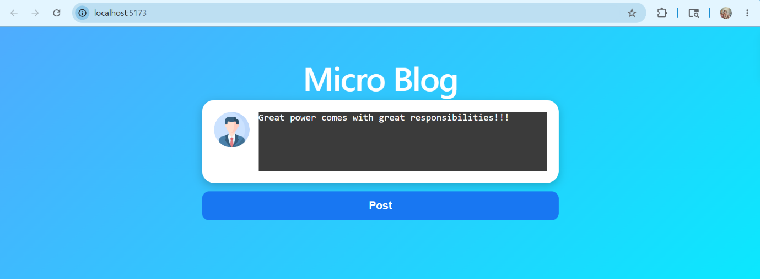
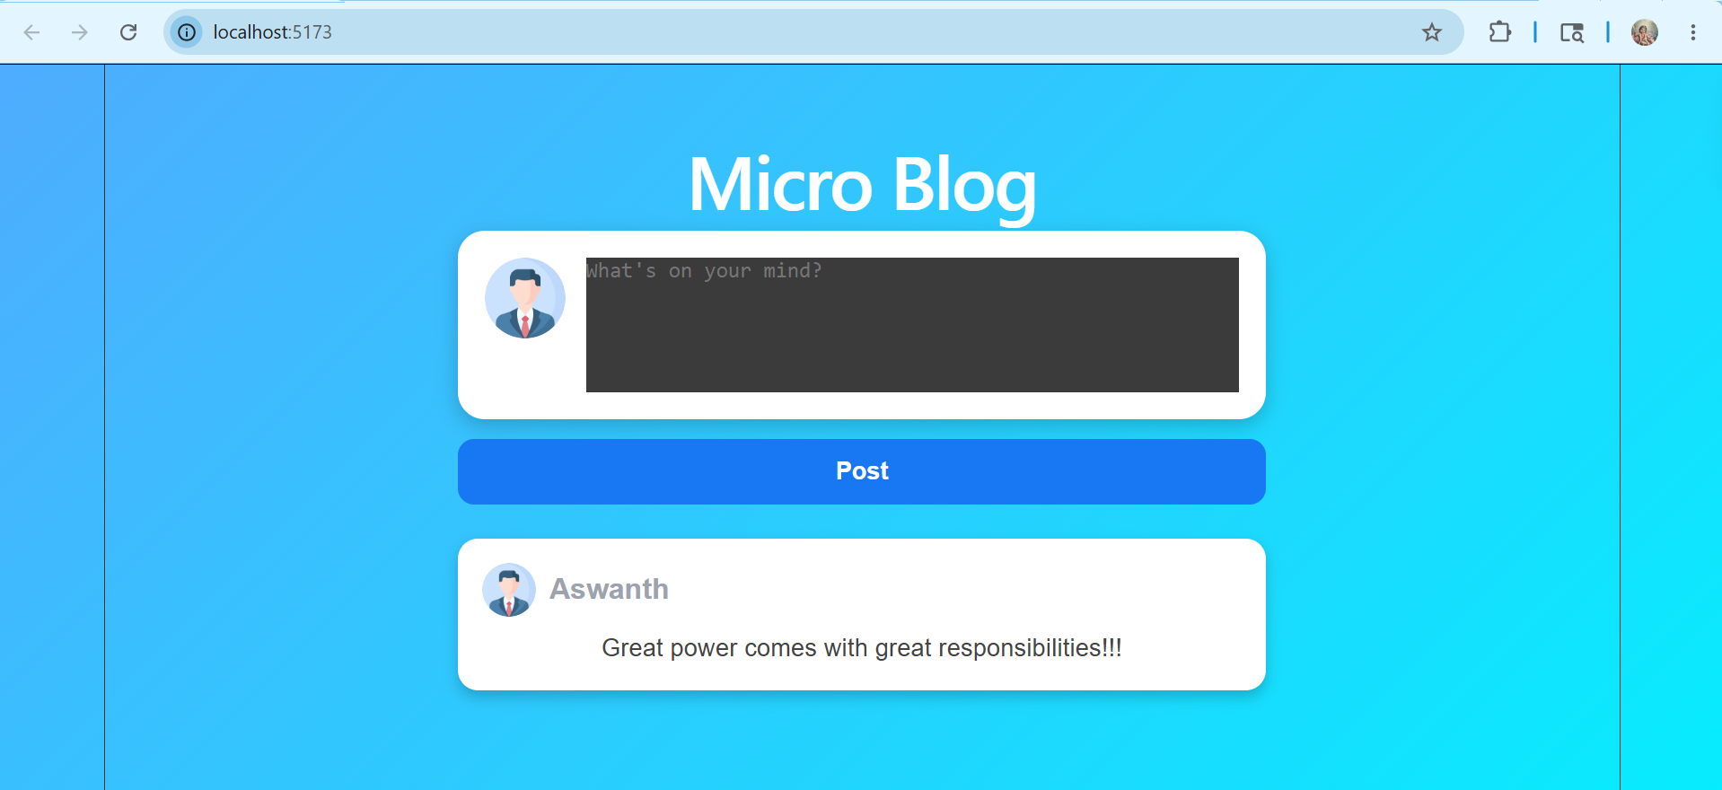

RESULT:
Thus, the micro blogging application using React JS was created successfully, allowing users to post and view content dynamically.

